** NAME:Aryaman Mishra**

**REG. NUMBER: 19BCE1027**

**EXPERIMENT NO.2**

**DATE:28-1-22**

**PSYCHOLOGY LAB RECORD BOOK FORMAT**

* **TITLE OF THE EXPERIMENT**

Rosenberg's Self-Esteem Scale

* **AIM:**

To compare group and individual scores obtained from the Rosenberg Self-esteem Scale.

* **MATERIALS REQUIRED:**

Rosenberg Self Esteem Scale Website,Graphs,Google Form Data

* **DESCRIPTION OF TEST:**

The Rosenberg self-esteem scale (RSES), developed by the sociologist Morris Rosenberg, is a [self-esteem](https://en.wikipedia.org/wiki/Self-esteem) measure widely used in social-science research. It uses a scale of 0–30 where a score less than 15 may indicate a problematic low self esteem. The RSES is designed similar to the social-survey questionnaires. Five of the items have positively worded statements and five have negatively worded ones. The scale measures global self-worth by measuring both positive and negative feelings about the self. The original sample for which the scale was developed consisted of 5,024 high-school juniors and seniors from 10 randomly selected schools in [New York State](https://en.wikipedia.org/wiki/New_York_State). The Rosenberg self-esteem scale is considered a reliable and valid quantitative tool for self-esteem assessment.

* **PROCEDURE**

Scores are calculated as follows:

*For items 1, 2, 4, 6,*and*7:*

|  |
| --- |
| Strongly agree = 3 |
| Agree = 2 |
| Disagree = 1 |
| Strongly disagree = 0 |

*For items 3, 5, 8, 9,*and*10* (which are reversed in valence):

|  |
| --- |
| Strongly agree = 0 |
| Agree = 1 |
| Disagree = 2 |
| Strongly disagree = 3 |

The scale ranges from 0-30. Scores between 15 and 25 are within normal range; scores below 15 suggest low self-esteem.

* **TABLE 1:**

**INDIVIDUAL DISCUSSION**

High self-esteem means generally holding yourself in positive regard. This doesn't mean you love everything about yourself or think you are perfect. On the contrary, even for those with high self-esteem, it's common to be self-critical and have some parts of yourself that you are less proud of or happy with than other elements. High self-esteem can fluctuate depending on the circumstance. Essentially, high self-esteem is a frame of mind that lets you celebrate your strengths, challenge your weaknesses, and feel good about yourself and your life. It allows you to put daily ups and downs in perspective because, at your core, you value, trust, and respect yourself.

High self-esteem also helps you understand that everything isn't about you, enabling you to not take everything personally and not be overly reactive. Strong self-respect lets you see beyond yourself and feel confident of your place in the world.

Interestingly, having high self-esteem does not always align with the circumstances or qualities that you might objectively assume should correlate with feeling good about yourself.

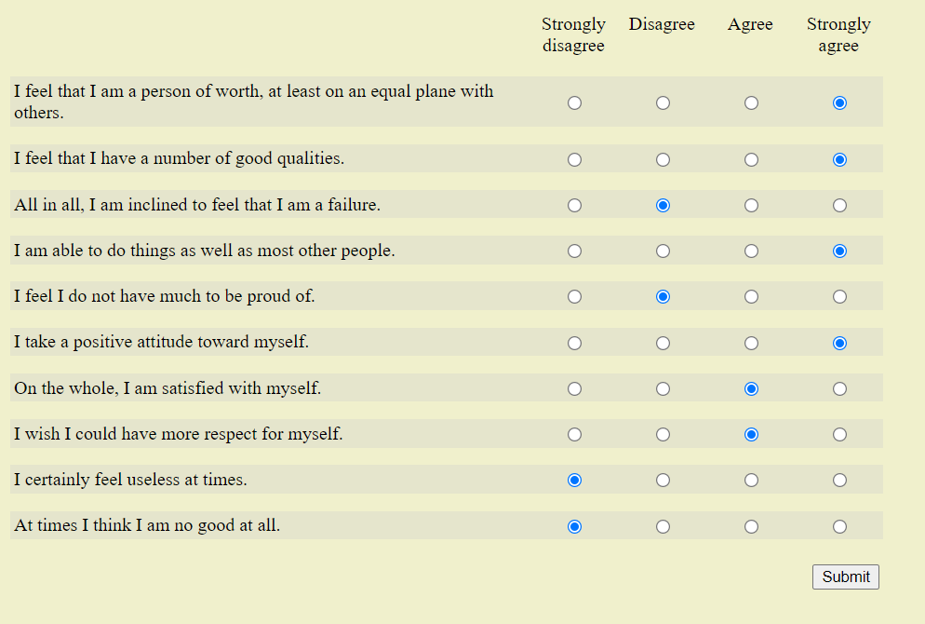

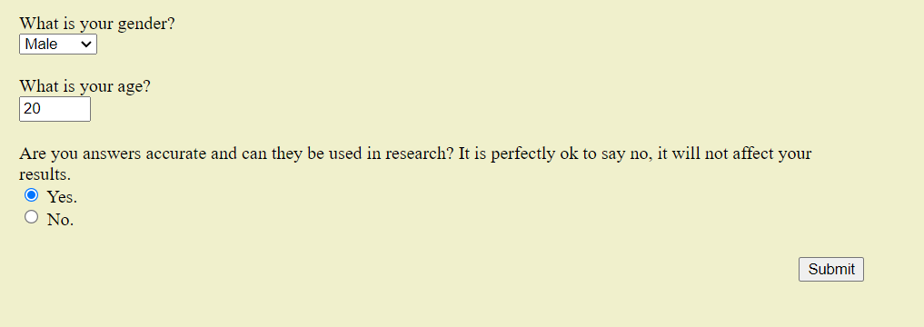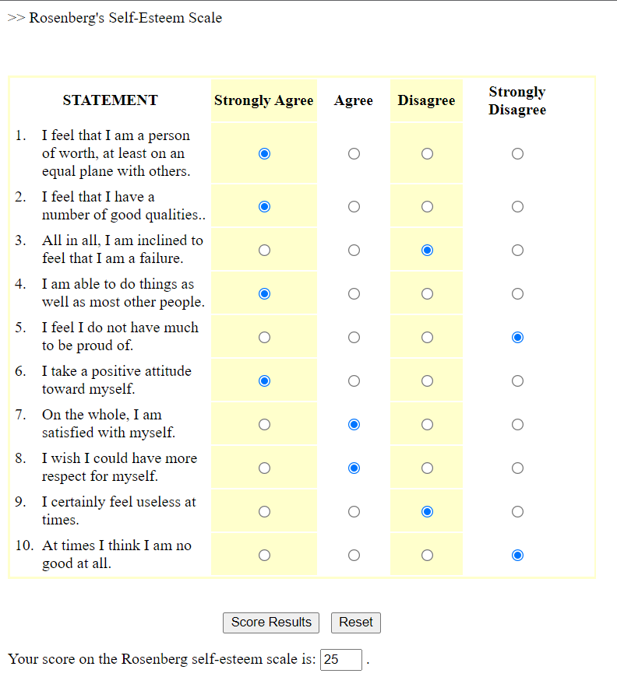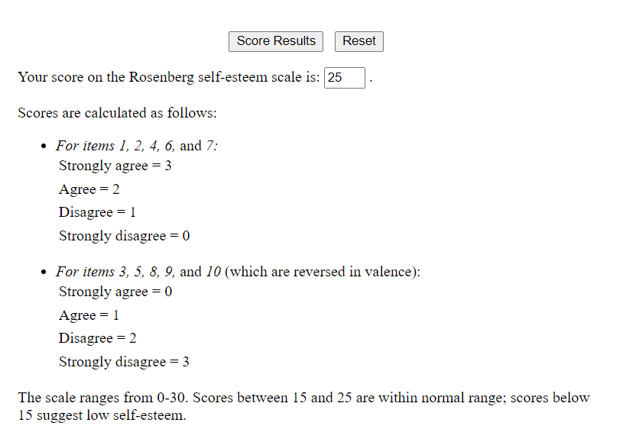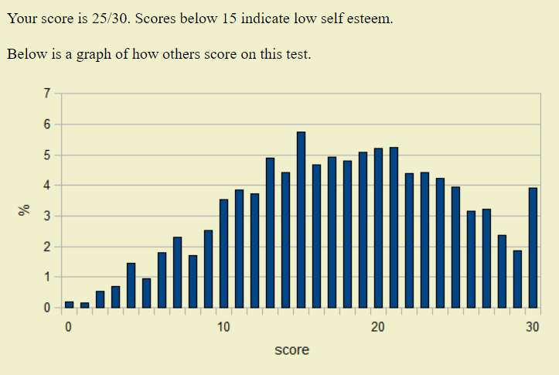

* **TABLE 2:**

**GROUP DISCUSSION**

Self confidence gives us the freedom to commit mistakes and cope with failure without making us feel worthless.If only we have confidence in ourselves, can we gain confidence of others. After all, most people are reluctant to back a project thats being pitched by someone who is nervous, fumbling and overly apologetic. On the other hand, you might be persuaded by someone who spoke clearly, who held his or her head high, who answered questions assuredly, and who readily admitted when he/she did not know something.

Recognize your insecurities: We all have insecurities in life. It can be anything from acne, to regrets, to friends at school. Giving a name to the things which make you feel unworthy, ashamed or inferior helps to combat them. You can try to pen down your thoughts and you will find that it makes you feel much lighter and happier. Remember that no one is perfect. The man or woman sitting next to you might have the same amount of insecurities as you have. If writing doesnt come easily to you, you might want to talk it out with your friends or loved ones. Sharing your thoughts will help relieve the burden you have been carrying all alone. Identify your successes: No matter how insecure you might feel, God has blessed each one of us with some talent. Discover the things you are good at and then focus on improving them. Give yourself permission to take pride in your talents. Give yourself credit for your successes. Inferiority is a state of mind in which youve declared yourself a victim. Do not allow yourself to be victimized. Be thankful for what you have: A lot of the times, at the root of insecurity and lack of confidence is a feeling of not having enough of something, whether its emotional validation, good luck, money, etc. By acknowledging and appreciating what you do have, you can combat the feeling of being incomplete and unsatisfied. Finding that inner peace will do wonders for your confidence. Be positive: Avoid self-pity or sympathy of others. Never allow others to make you feel inferior they can only do so if you let them. If you continue to loathe and belittle yourself, others are going to do and believe likewise. Instead, speak positively about yourself, about your future, and about your progress. Do not be afraid to project your strengths and qualities to others. Dress sharp: Although clothes don't make the man, they certainly affect the way he feels about himself. When you dont look good, you dont feel good. It changes the way you carry yourself and interact with people. This doesn'tt mean you need to spend a lot on clothes. Rather than buying a bunch of cheap clothes, buy half as many select, high quality items. In long run this decreases spending because expensive clothes wear out less easily and stay in style longer than cheap clothes. Walk faster: Your gait tells a lot about your personality. Is it slow? Tired? Painful? Or is it energetic and purposeful? People with confidence walk quickly. They have places to go, people to see, and important work to do. You can increase yourself confidence by putting some pep in your step. Walking 25% faster will make to you look and feel more important. Compliment other people: When we think negatively about ourselves, we often project that feeling on to others in the form of insults and gossip. Refuse to engage in backstabbing gossip and make an effort to compliment those around you. In the process, youll become well liked and build self confidence. By looking for the best in others, you indirectly bring out the best in yourself. Take the front seat: Back benchers might seem to have a lot of fun in schools and colleges but that does nothing to boost their self confidence. Don't be afraid to get noticed. By deciding to sit in the front row, you can get over your irrational fear of getting noticed and build your self confidence. Speak up: Its a general observation that many people are afraid to speak or ask questions in a group discussion or a public gathering. They are afraid that they might be judged for saying something stupid. Generally, people are much more accepting than we imagine. In fact most people are dealing with the exact same fears. By making an effort to speak up at least once in every group discussion, you'll become a better public speaker, more confident in your own thoughts, and recognized as a leader by your peers. Work out: A healthy mind resides in a healthy body. If you are fit, you are surrounded by positivity and energy. If you are out of shape you feel unattractive. This leads to demoralization. Just a little discipline in your life can help shape up your self confidence in a big way. Smile: Last but not the least; try to smile as much as possible. People are always appreciative of a smiling face. You will be welcomed by anyone who comes in your contact. A smiling face is always received with warmth and affection. Acceptance and recognition from others helps in building self confidence.

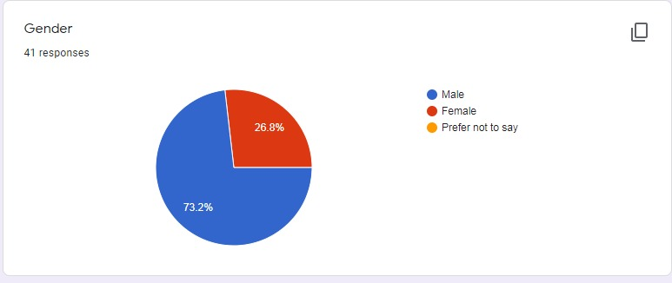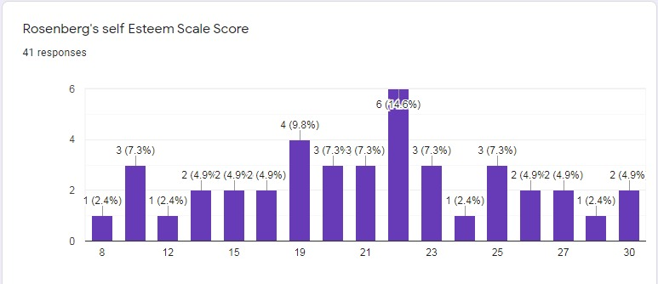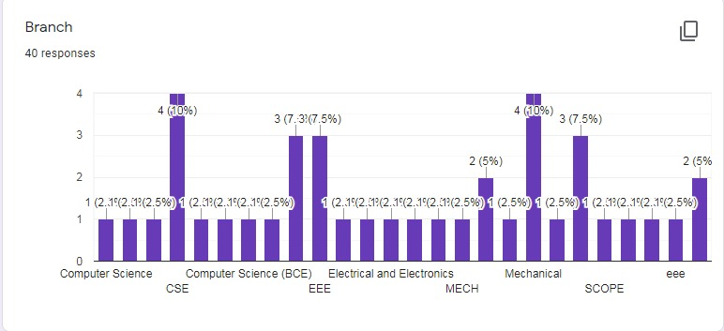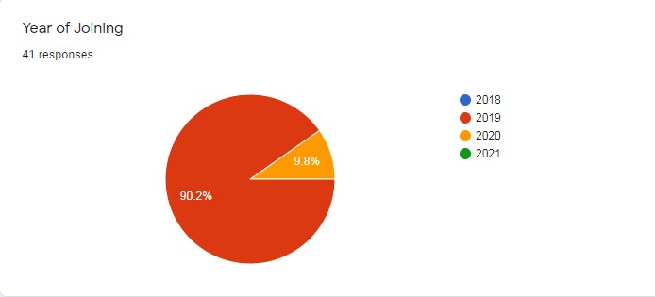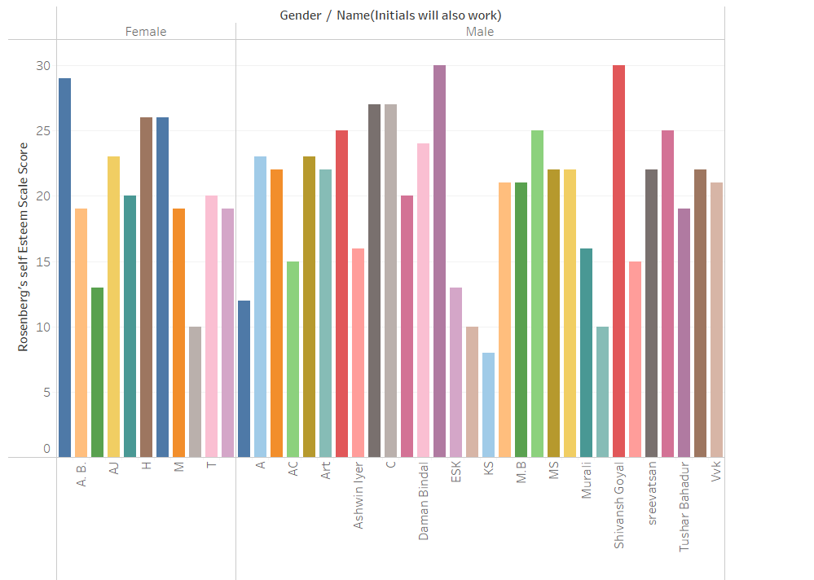

* **CONCLUSION**

From the data provided,it can be concluded that Males tend to have a higher Self Esteem as compared to Females.

­­­­­­­­­­­­